**JEE Mains MongoDB database screenshots:**

Query to find all records

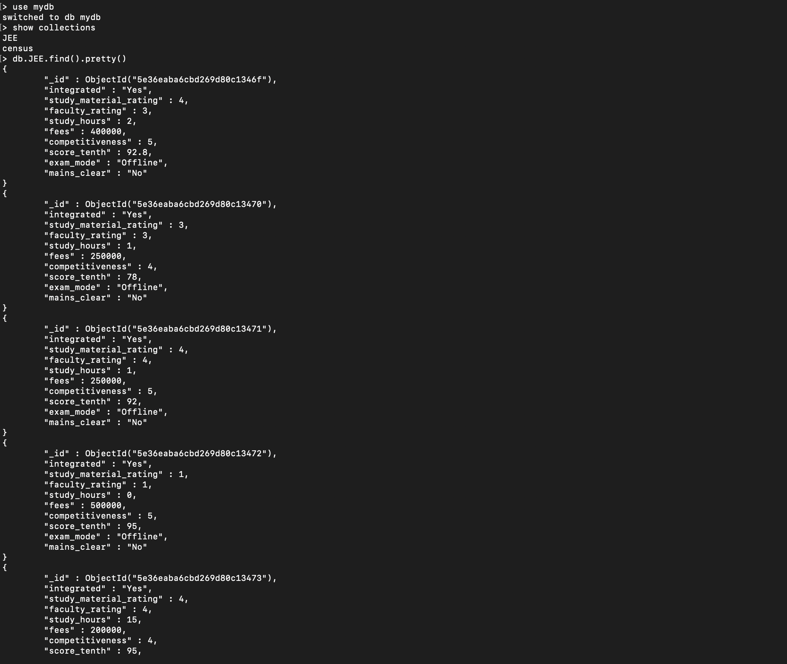

Query to find students who cleared JEE Mains:

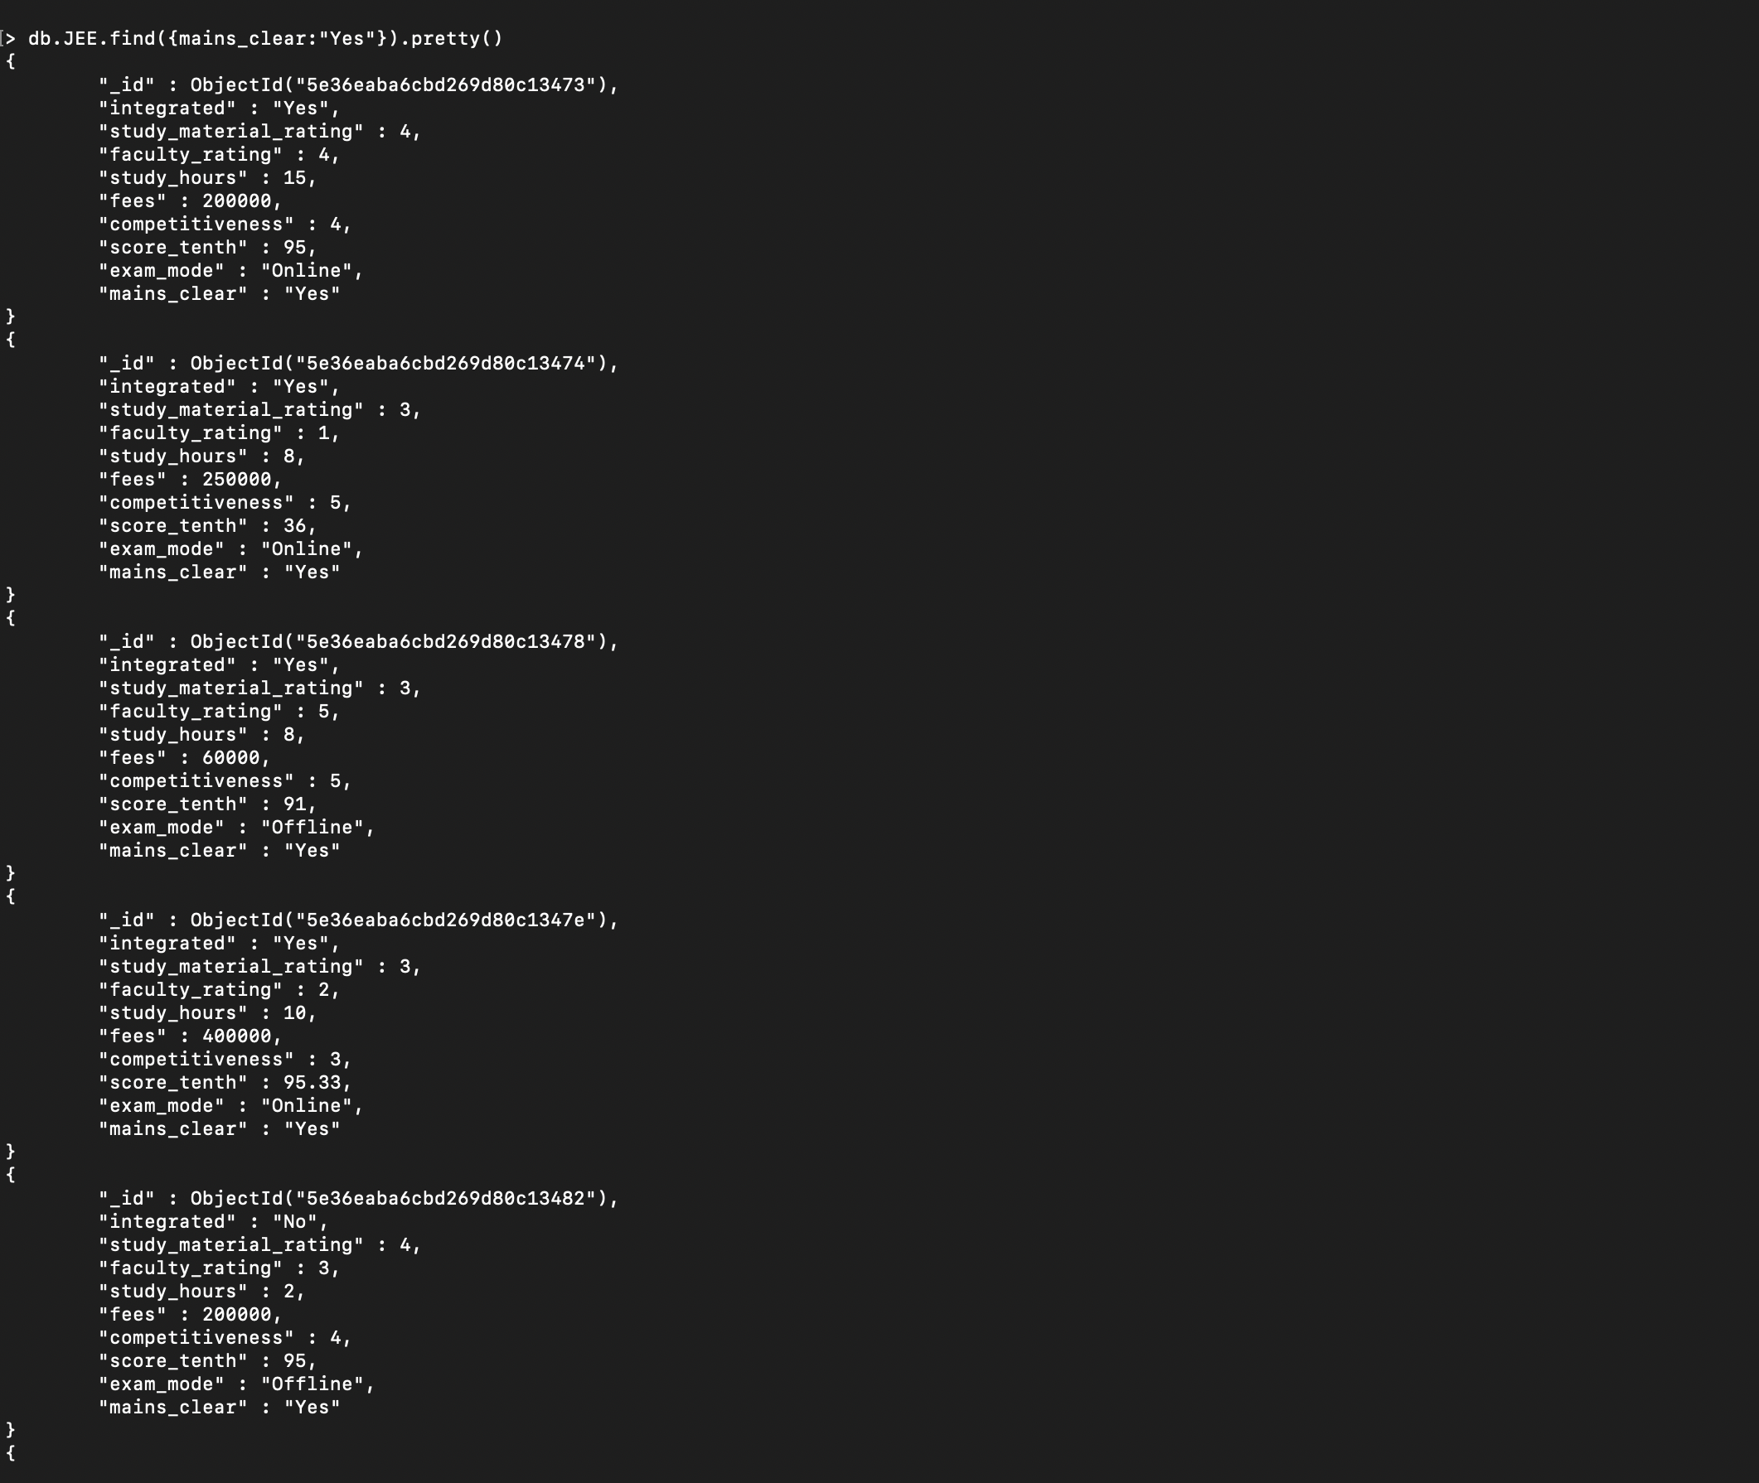

Query to find all students who cleared JEE Mains and paid fees less than 200000:

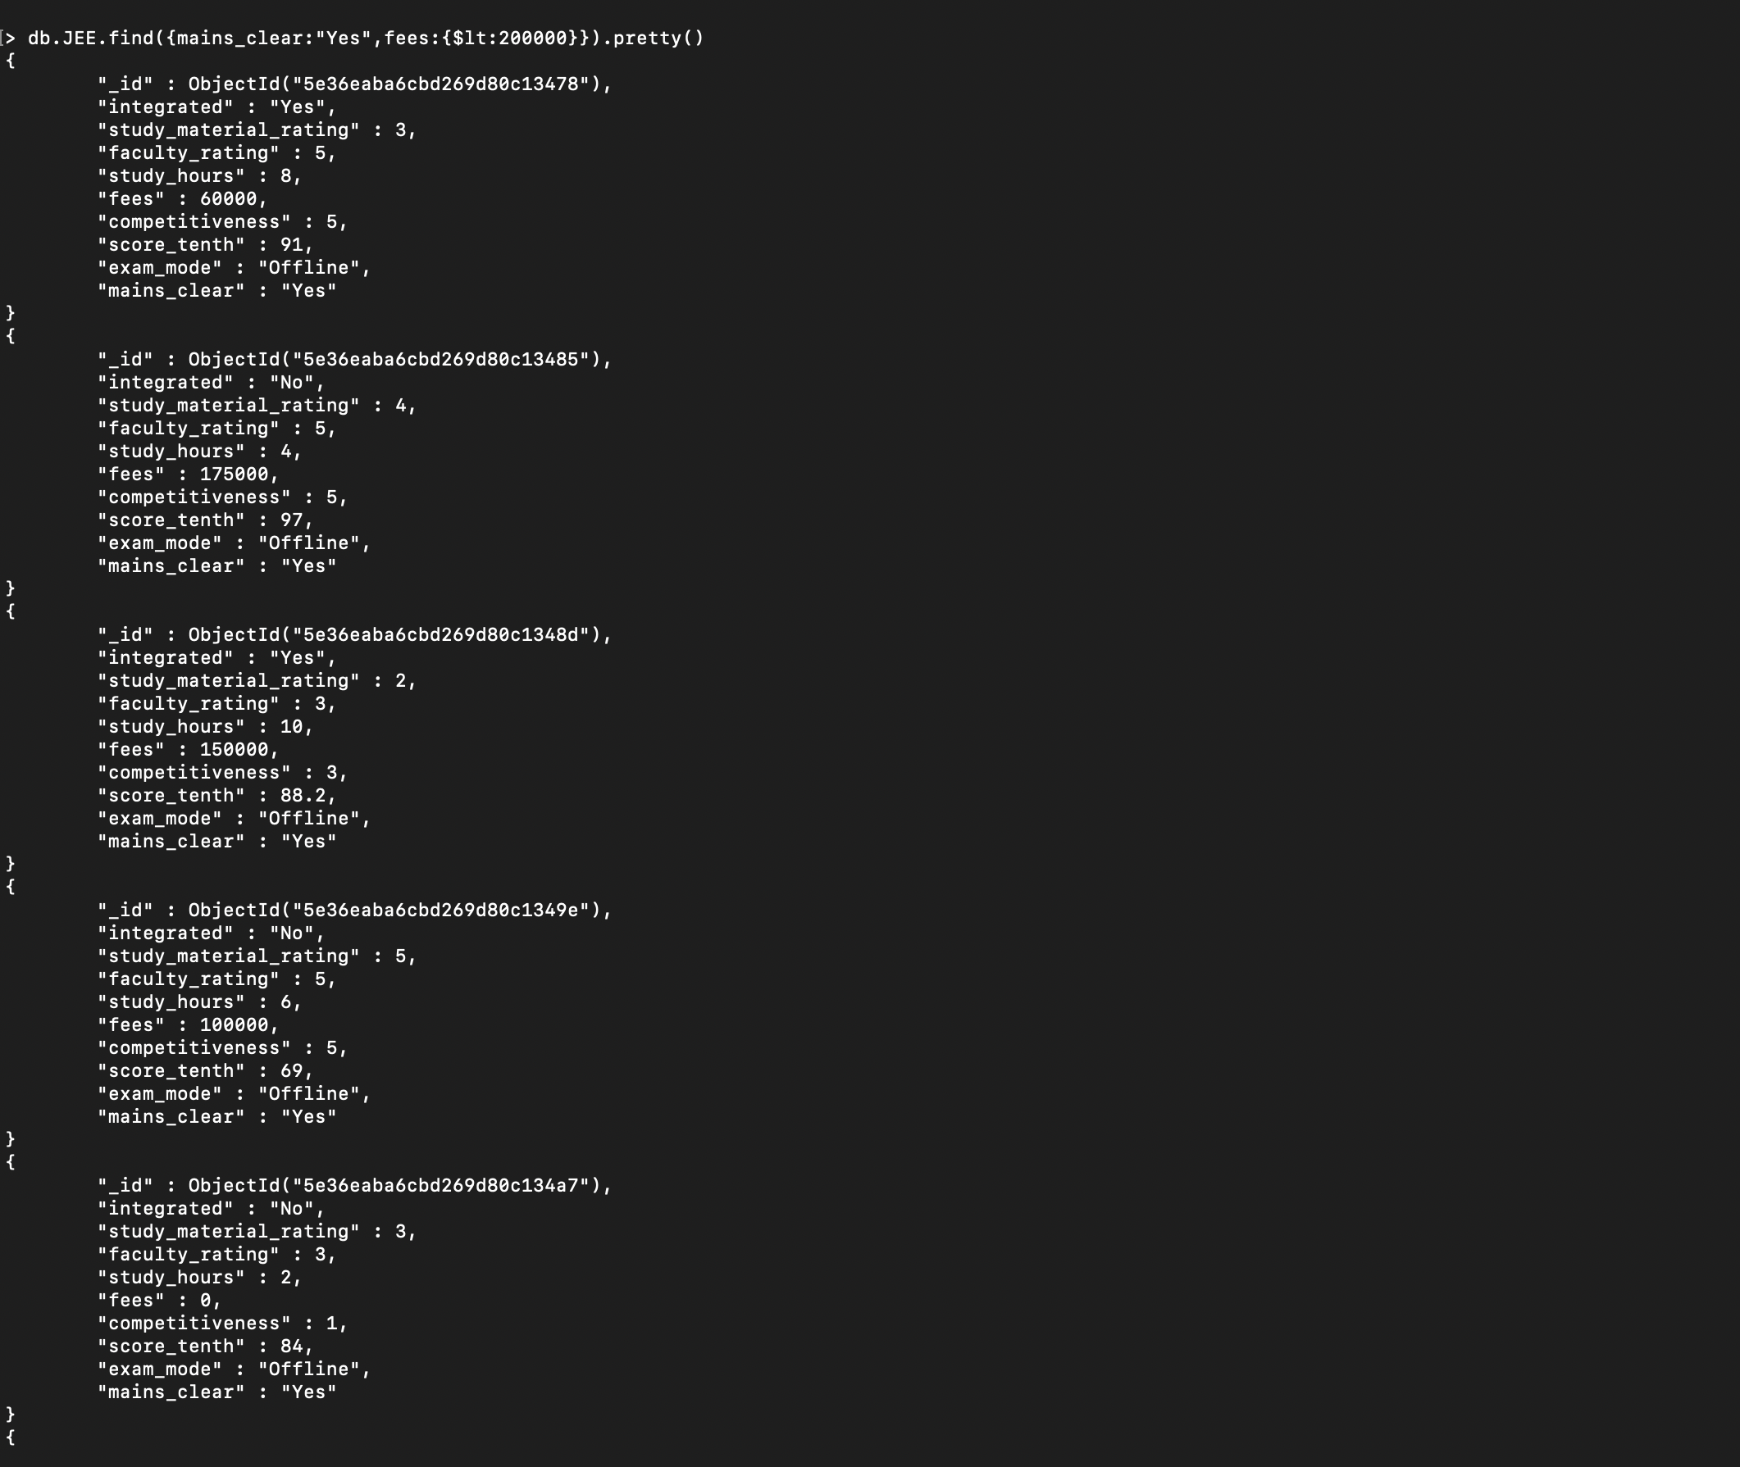

Query to find students who cleared JEE Mains with coaching competitiveness rating greater than 3,faculty rating greater than 3, fees less than 200000 and attempted offline Examination mode.

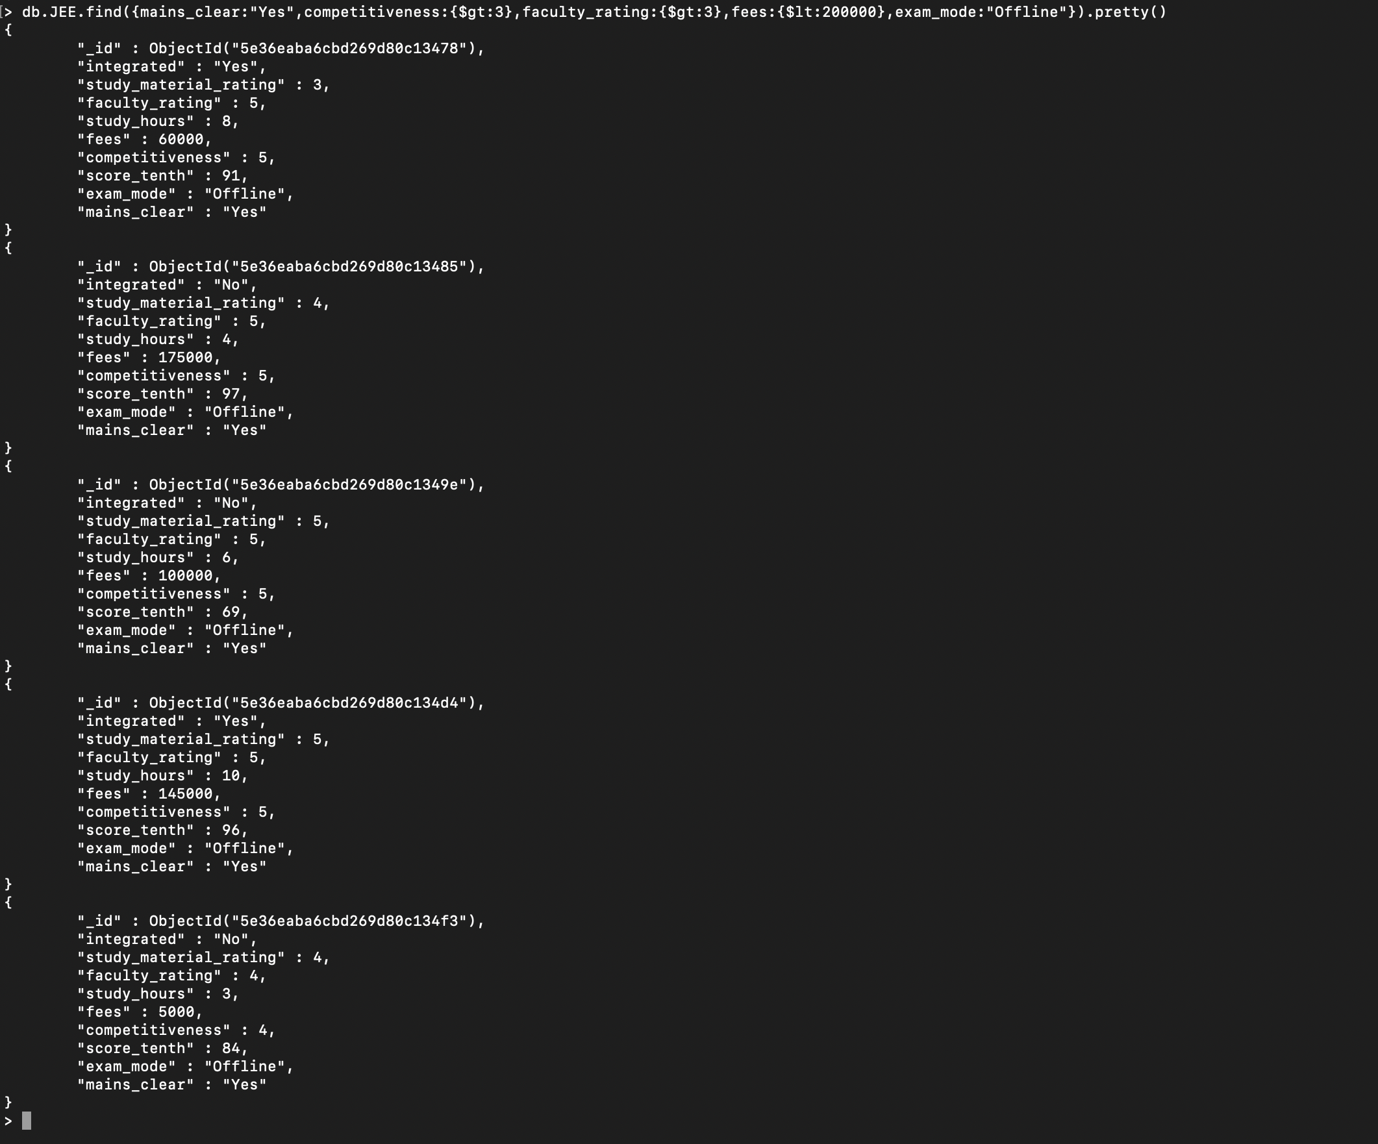

Query to find Number of Students who cleared JEE Mains:

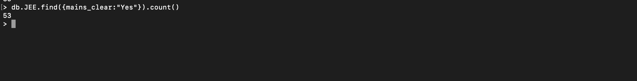

Query to find count of students who cleared JEE Mains and attended integrated coaching classes:

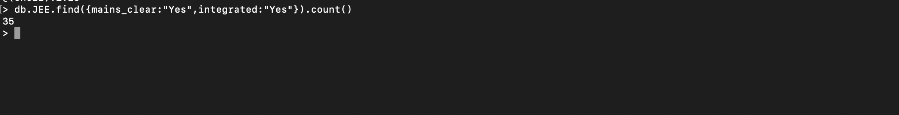

Query to find distinct values of Fees:

